***Command Line Techniques and Directory Navigation***

**Commands:**

**ls – List:**

It will show all the folders inside the directory.

ls is linux command use **dir** command in windows that’s similar to ls command in linux.

**cd - change directory:**

to change the location

Let’s make long path

Current directory is

**D:\>**

Make long directory

**cd university\Web Notes\JavaScript**

Use up and down buttons to select previously selected directories

**Previous Commands History:**

Press F7 to go to commands history.

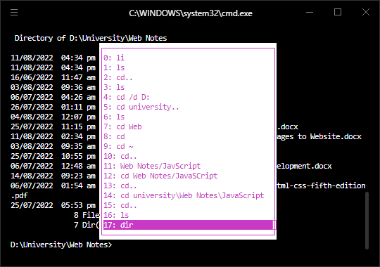

Shortest way to set directory:

Write cd and drag the path in command prompt

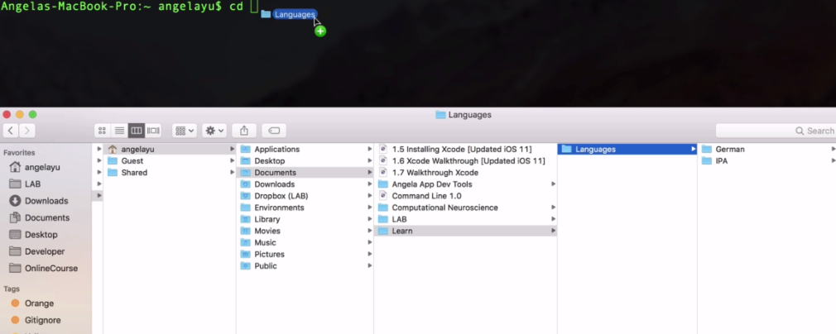

Go back:

**cd.. or cd ..**

**GUI:**

cd drag folder here and edit any part you want by moving using left and right buttons.



<https://github.com/0nn0/terminal-mac-cheatsheet>